Krishnamurti Speaks about His Discovery by Leading Theosophists

[Interview by Wilfred Thomas
Urgency of Change: The Krishnamurti Podcast, Episode 32
This interview by Wilfred Thomas with Krishnamurti took place at the recently-purchased Brockwood Park in Hampshire. It was recorded for Australian radio.
Courtesy Krishnamurti Foundation Trust, England
Krishnamurti at Brockwood Park, 1 June 1970]

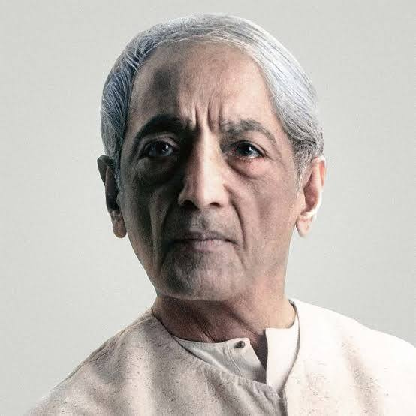
Wilfred Thomas: Krishnamurti, how old were you when you first heard about the Theosophists’ plans for you?
Krishnamurti: I must have been about ten. I don’t remember exactly.
WT: You don’t remember how it felt at the time?
K: No, not at all.
WT: Did you really believe that you were the chosen one?
K: No, sir. May I tell you something? When they found us we were a very poor family and all the rest of it, Brahmins, and I’m afraid I can’t tell you with direct memory because I don’t remember it actually. I’m not pretending, I’m just stating facts. I believe when they found us we were very weak and one of the principal people who found us said, ‘He is going to be a great teacher,’ and so on, so on, so on. They formed an organisation around me. I was the head of it and there were thousands of members, money – you know, all the business of it.
WT: They didn’t use any drugs or hypnosis or anything like that?
K: For goodness sake, no. They are not that kind of people. They were very, very serious. They weren’t charlatans. They weren’t using a good old gimmick or trick to exploit people. They really – please believe me – sincerely believed what they were doing. It wasn’t just a hoax. It wasn’t to exploit people. They staked all their reputation, all their work, everything on this boy. So there was no question of drugs or hypnosis or suggestions made. They said, ‘This boy is going to be used by the great teacher,’ in whom they believed absolutely.
WT: And why did they believe this? Why did they believe that you had been chosen?
K: Because they were clairvoyant.
WT: They really were.
K: Probably they were. At the time they discovered the boy they certainly must have been, because they said, ‘This boy is going to be the great teacher. His body will be used.’ Whether you – it’s not a question of your belief, I’m just telling you what they sincerely, honestly and deeply believed. They believed because they said this happens every two thousand or whatever years, a great teacher appears on earth when the world is in chaos and he will give new kind of teachings and so on. That’s their fundamental, radical belief.
WT: They had some sort of occult instructions?
K: Yes, instructions, which they believed and they followed it.
WT: And you did too, of course, at first. But when did you first have doubts about the pattern they’d laid down for you?
K: You see, I never had doubts. Forgive me, using that word. You see, the boy must have been very vague and not all there, if I can put it that way. I should think he must have been a very dreamy boy. And so whatever they said didn’t deeply penetrate. You see, I mustn’t… They had been looking for a number of years – from what people have told me – for a boy. They had already brought an American boy to India, I believe, and the moment they saw me they dropped him because they said, ‘This is the boy we have been looking for.’ For two years they watched over this boy and his brother, gave him the right kind of food and all that, brought him to Europe, educated him. Nothing penetrated deeply. And they had built a tremendous organisation around this boy. It wasn’t just for money, for exploitation, but they – please, you have to be convinced – they really believed what they were doing. So when this boy began to talk he said, ‘Organisations are not the way to truth,’ and dissolved it.
They were very, very serious. They weren’t charlatans. They weren’t using a good old gimmick or trick to exploit people. They really – please believe me – sincerely believed what they were doing. It wasn’t just a hoax. It wasn’t to exploit people. They staked all their reputation, all their work, everything on this boy.
WT: You just out of the blue decided that you didn’t want to have anything more to do with this particular programme, as it were.

K: No, with any religious organisation. Because it then becomes another sect, another division in the religious structure of man and say that’s all wrong, to divide people into Christians, Hindus, Buddhists and all the rest of it, he said it seems so absurd.

WT: This is a strange thing that you should have come to this conclusion. You must have studied a great deal.

K: No, I haven’t. If I may again say simply and very honestly, I don’t read any philosophy, any religious books. I read a weekly news magazine and occasionally a detective story, but otherwise I’m not a reader.

WT: It must have been a great blow to the Theosophical Society because it claimed this occult authority, and also to those who expected the coming of the World Teacher. Did the society close down then?

K: On the contrary; it is going on.

WT: It’s still going on?

K: Yes, of course.

WT: And when you dissolved the Order of the Star of the East you didn’t wish to set up a rival cult, obviously.
K: Good God, I didn’t want to…

WT: …have anything to do with it.

K: With any cult.

WT: But you still believe that you have a lot to teach.

K: I don’t believe; I do it.

WT: Well, what is the purpose of your mission to Australia?

K: First of all, they have asked me to go there. And I don’t go unless invited because I have no money. I don’t possess. I don’t want to, you know, go into all that kind of thing. So when they asked me, they have been asking me for several years to go.

WT: And you will be giving talks there.

K: Probably discussions, talks.

WT: People will undoubtedly come to you with some of their problems to discuss with you.
Do you welcome that sort of thing?

K: I don’t welcome or not welcome. If they want to see me, they will see me. If they don’t, they don’t. I don’t want to impress anybody. I want to be really totally anonymous. It isn’t a personal cult and all that rubbish.

WT: Of course, this is going to be a rather impertinent question, I’m afraid.

K: Do please, you can ask it.

WT: Australians of my generation may associate you with that amphitheatre the Theosophists built at Balmoral from which believers who bought seats could witness the second coming.
At least, that’s what the papers said. Is that what actually happened?
K: I believe so.
WT: That was after your time though, was it?
K: No. I don’t remember exactly. I think it must have been around ‘25, ‘26 or ‘27 – I don’t remember exactly. They started something of that kind. But when I dissolved all – you follow? – all that kind of thing, they said, ‘Lord!’ – you know?
WT: Of course, that helped to rather discredit the Society I should have thought.
K: No, you see, sir, you must keep the two things clear. The Society was one thing and the Order of the Star was in the other. The Society believed in brotherhood and all that kind of stuff, and the Order of the Star expressly believed that they would follow what the teacher would say. So when that was dissolved the Theosophical Society went on.

